Cleanliness Requirement Comparison for Shredding and Recycling

— PET vs PP vs PA vs PC

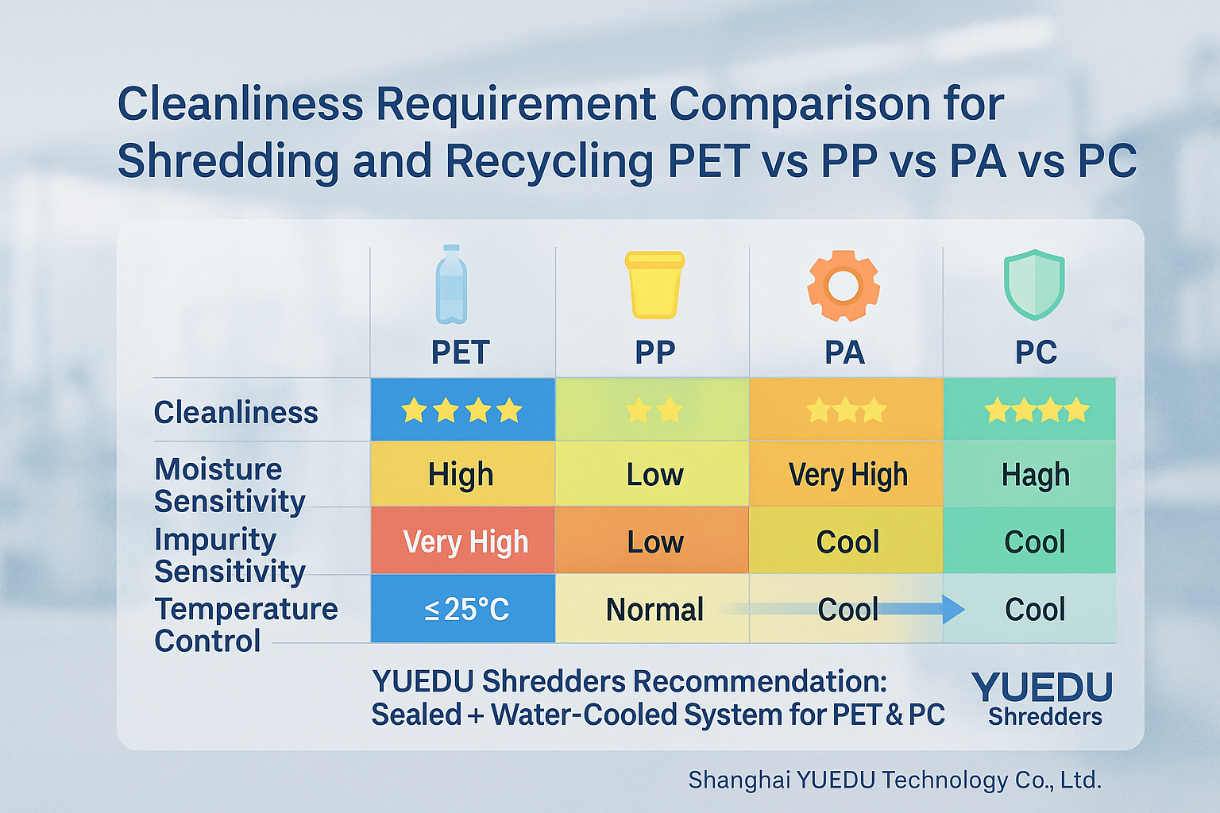

✅ Summary:
- PET and PC both require very high cleanliness; shredding systems must include dust-proofing, cooling, impurity separation, and static control.
- PP is the most tolerant and suitable for standard shredders.
- PA is sensitive to both moisture and impurities; use engineering-grade shredders.
- For closed-loop recycling or high-purity granulation, a sealed, dust-extraction, water-cooled, and metal-separation system is strongly recommended.
Item | PET (Polyethylene Terephthalate) | PP (Polypropylene) | PA (Nylon / Polyamide) | PC (Polycarbonate)
Application Features | Bottles, fibers, food packaging, high-clarity films | Containers, appliance shells, automotive parts | Engineering parts, gears, electronic components | Optical disks, transparent covers, safety enclosures
Temperature Control During Shredding | Low-temperature shredding (≤25°C) to prevent melting/degradation | Normal temperature control is sufficient | Water-cooled shredding recommended to prevent deformation | Cooling required to avoid yellowing and decomposition
Cleanliness Requirement | ⭐⭐⭐⭐ Very High — Impurities >0.5% severely affect quality | ⭐⭐ Moderate — Can tolerate minor contamination | ⭐⭐⭐ High — Impurities reduce strength and friction resistance | ⭐⭐⭐⭐ Very High — Impurities cause transparency loss and cracks
Moisture Sensitivity | Very high, drying required ≤0.005% | Low | High, requires pre-drying | Moderate to high, drying recommended
Sensitivity to Impurities | Extremely sensitive; PVC/PP contamination lowers melting point | Low; tolerates minor foreign plastics | High; metal dust affects strength | Very high; impurities reduce optical performance
Post-Shredding Treatment | Washing + Drying + Dust & Metal Separation | Washing + Drying (optional) | Drying + Dust Removal | Washing + Drying + Anti-static
Recommended Equipment | Sealed dust-free system + water-cooled shredder (e.g. YD-SL600) | Standard shredder (e.g. YD-PSJ400) | Engineering-grade shredder (e.g. YD-PSJ500W) | Sound-proof + cooled shredder (e.g. YD-SL350W)

🌐 Contact Us
Shanghai YUEDU Technology Co., Ltd.
📞 Contact Us to explore more customized models and tailored shredding solutions that suit your specific needs!
Let us help you find the perfect equipment for your application.
📱 Sales Supervisor: +86 159 0178 2779 (WhatsApp / WeChat / Facebook)
📱 Administrative Supervisor: +86 137 6138 5116
📧 Email: yuedushredders@gmail.com | denghao8410@gmail.com
🌐 Website: www.yuedushredders.com
@YUEDUShredders – Empowering Global Industries with Intelligent Destruction Systems.

